xf



BINH LOI COMPANY LIMITED

HYDRAULIC ROTARY HEAD R1O/R12
MAINTENANCE INSTRUCTION AND
SPARE-PART BOOK

HÀ NỘI, THÁNG 1/ 2015
CÔNG TY TNHH CÔNG NGHIỆP NỀN MÓNG nnnnnnnnnnnnnnnnnnnnnnnnnTEL: 04.3.2595106 FAX: 04.3.2595107

GIỚI THIỆU NĂNG LỰC

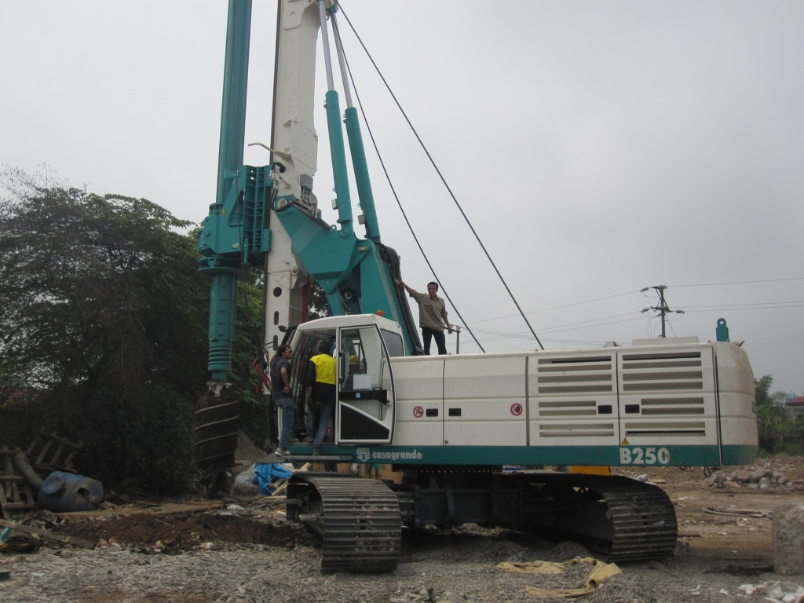

ơi nhận:
Địa chỉ:

HÀ NỘI, THÁNG 5/ 2010

BINH LOI COMPANY LIMITED
Address: No.101/189 – Hoang Hoa Tham street – Ba Dinh District – Hanoi – Vietnam
Tel: ++84-24-3722 6115
Fax: ++84-24-3722 6119
Email: info@binhloi-machinery.com
sale01.binhloi@gmail.com
Website: http://binhloi-machinery.com/ or http://binhloi-machinery.vn/

DEVICE WORKING POSITTIONS

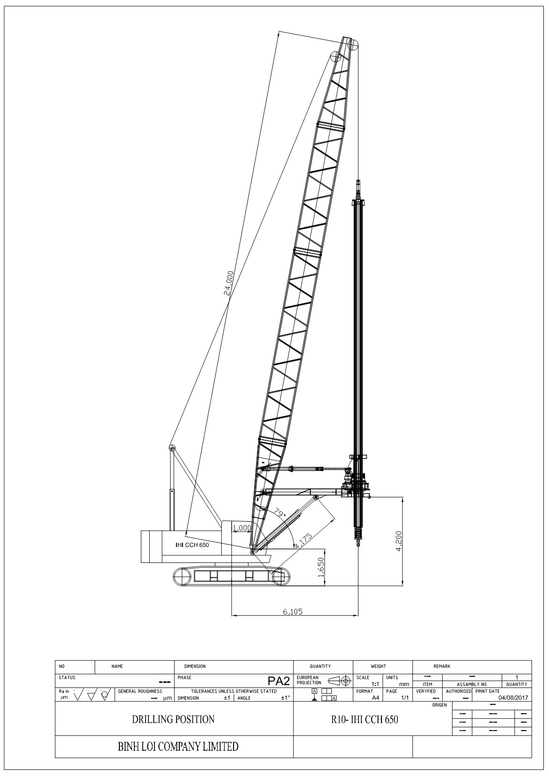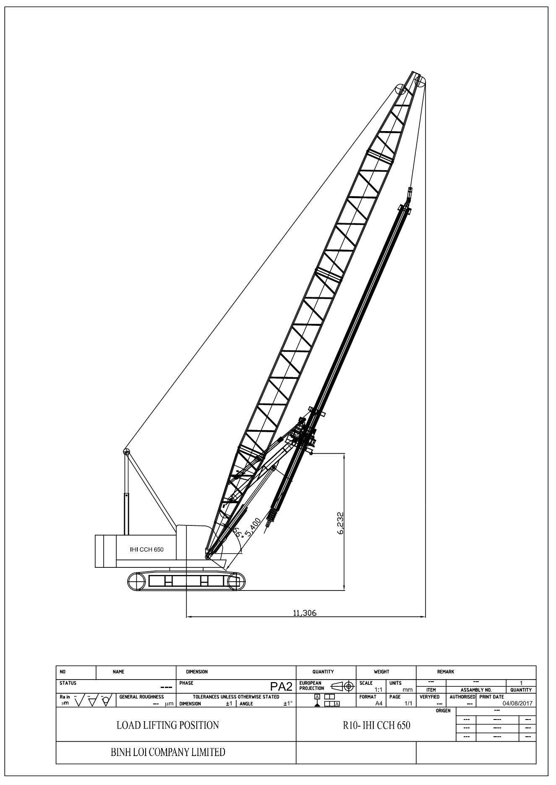
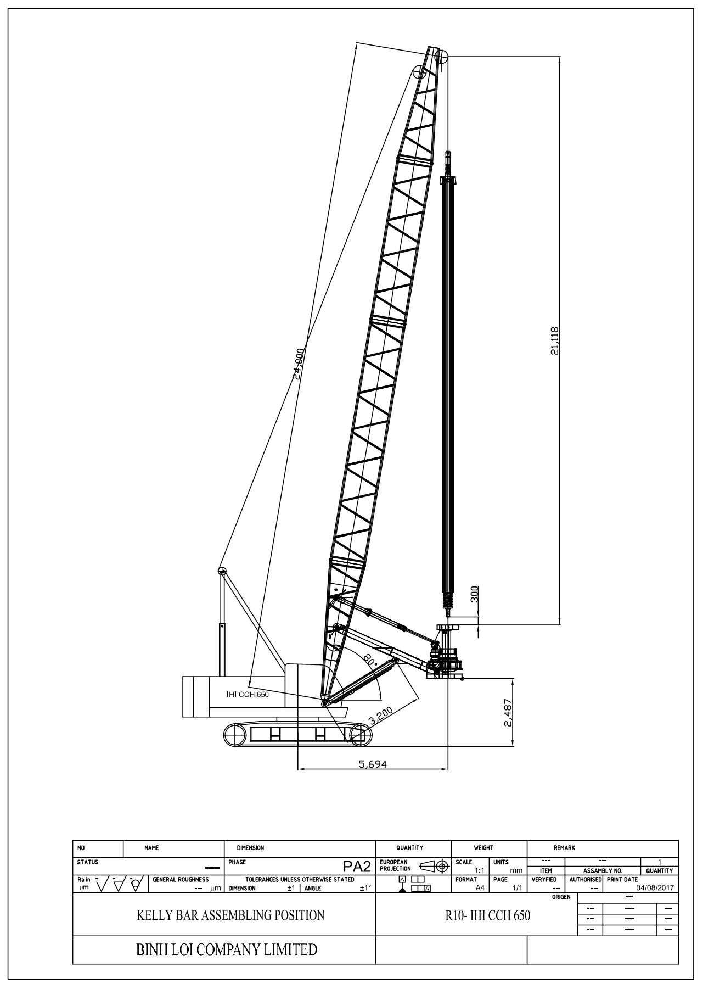
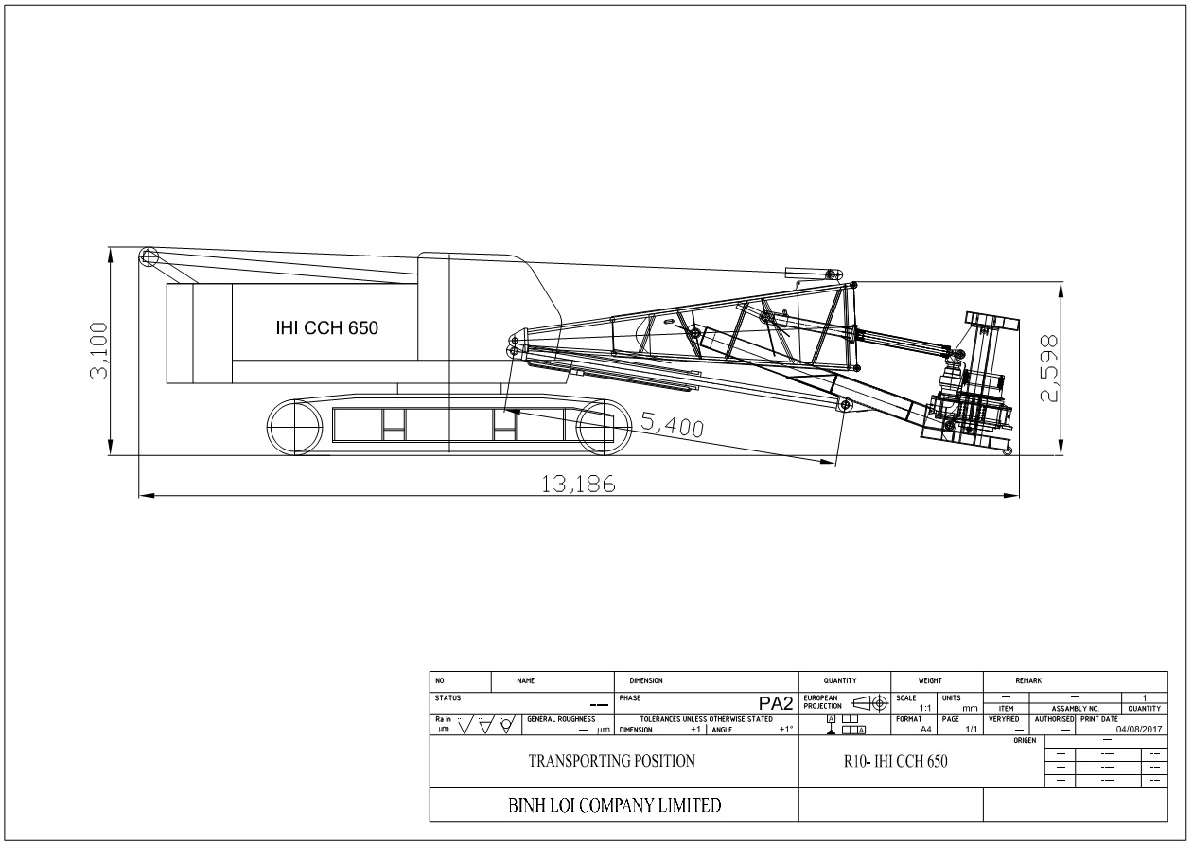

SPARE PARTS
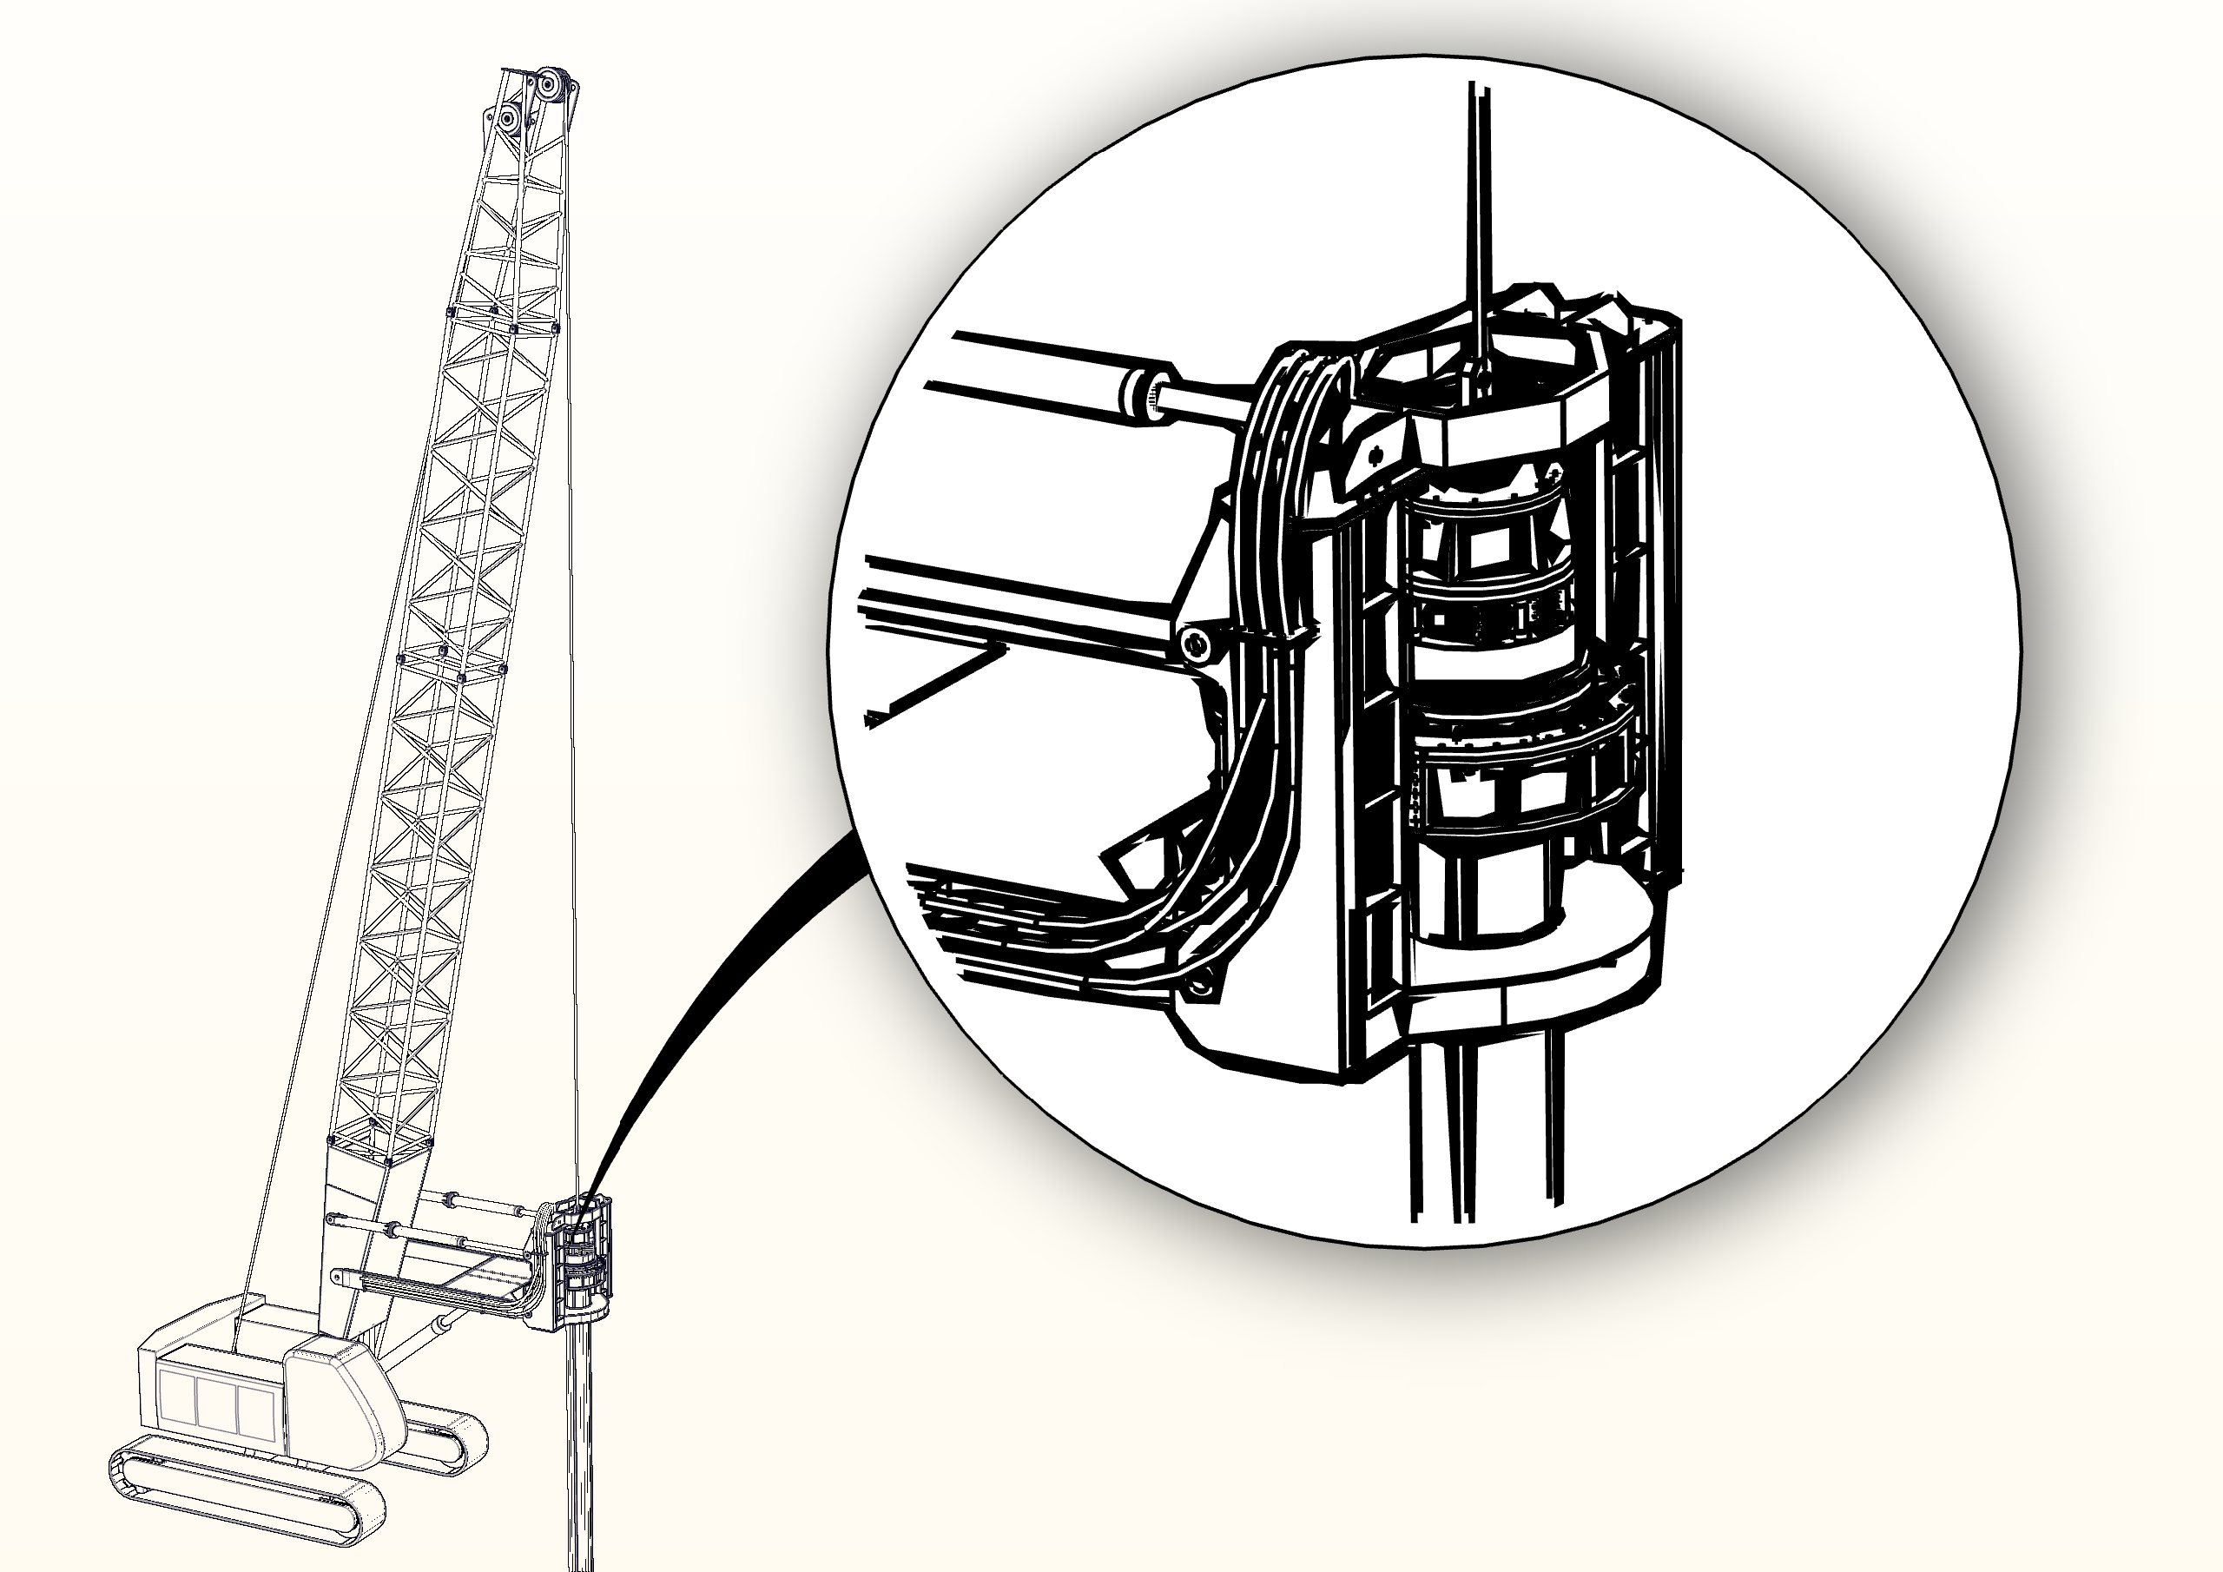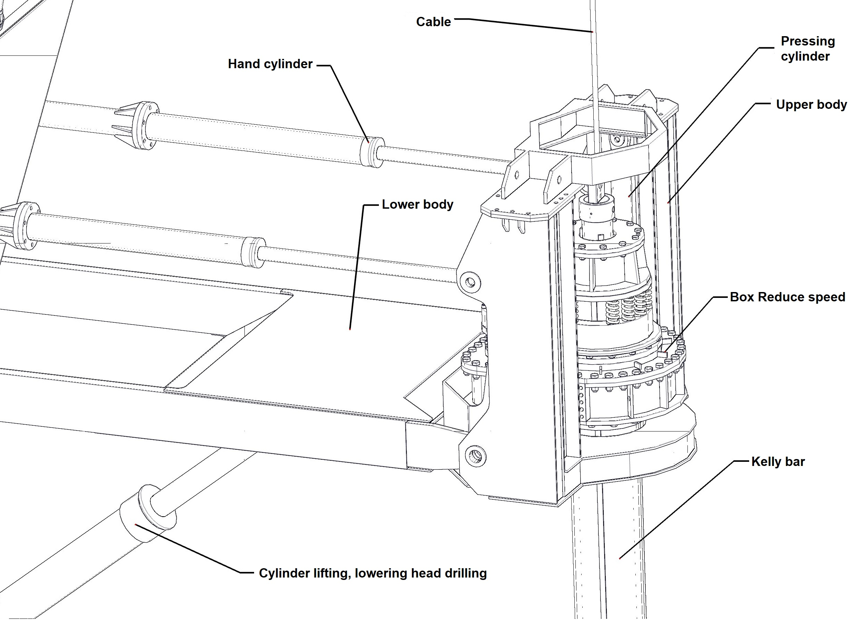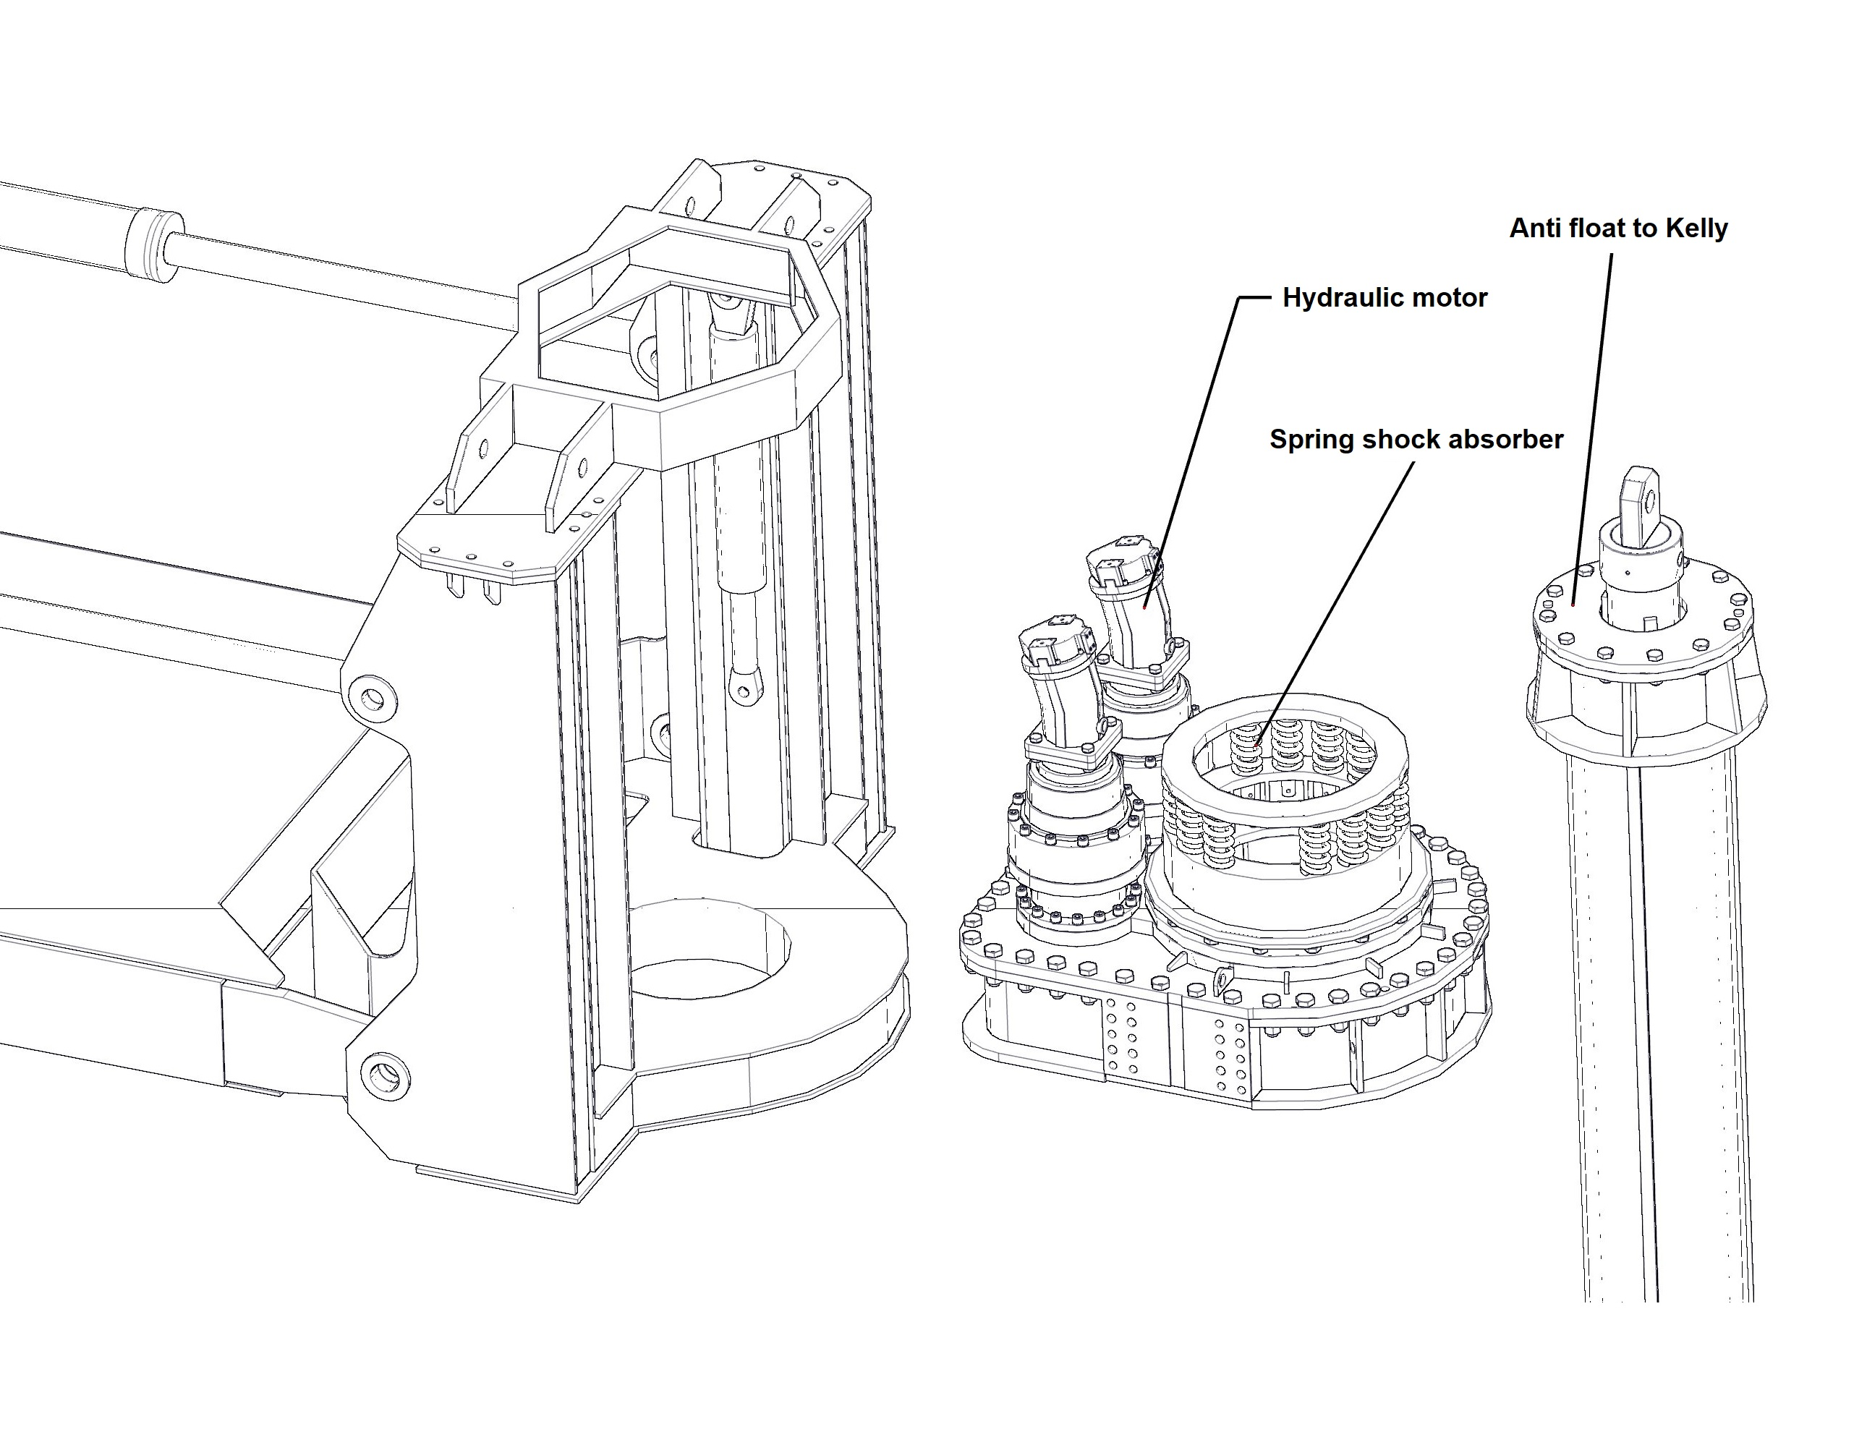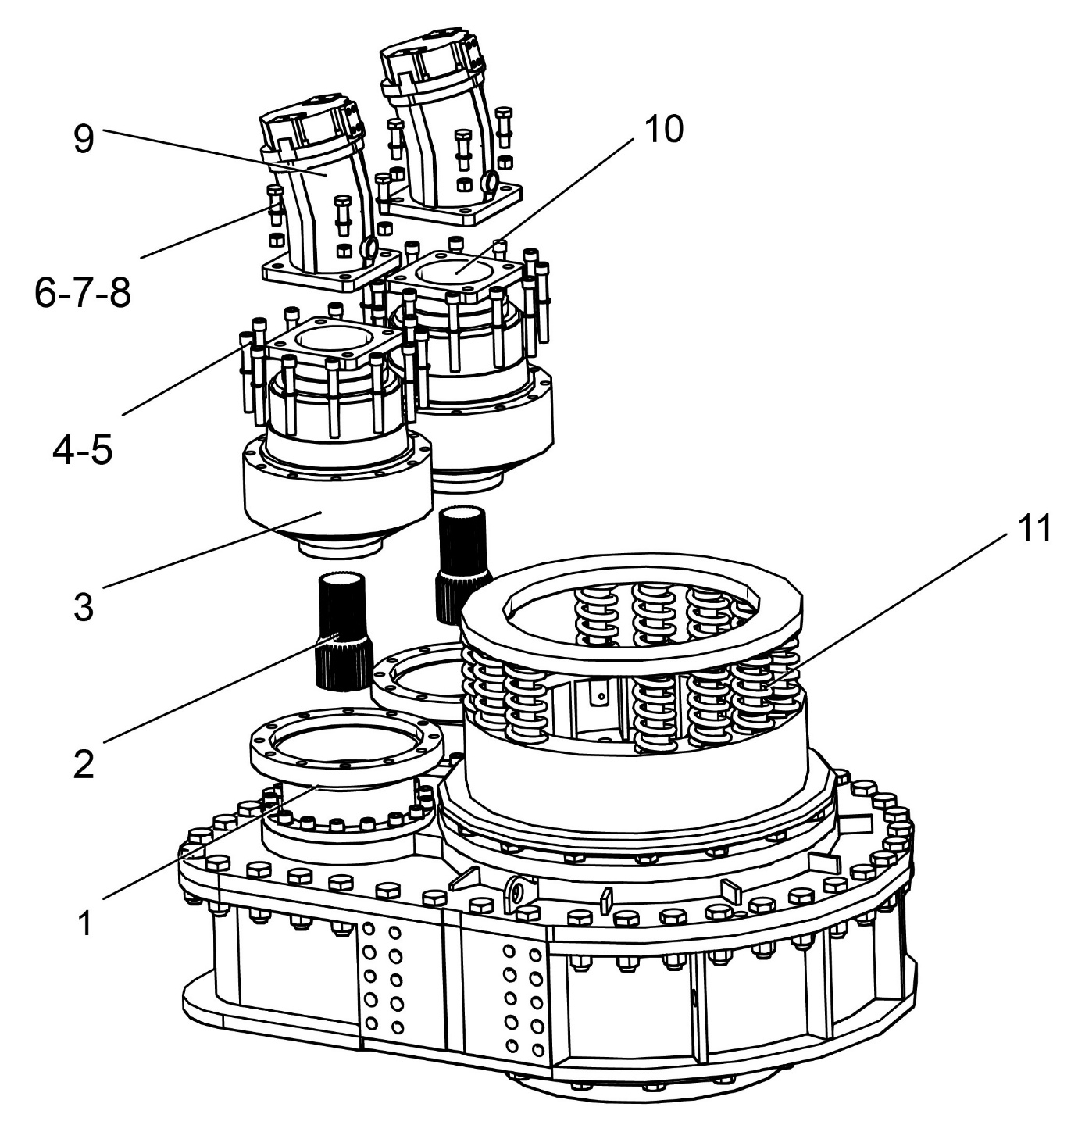

ITEM NO | PART NUMBER | Q’TY | DESCRIPTION
1 | 100001 | 2 | Reduction box adapter
2 | 100002 | 2 | Splined shaft
3 | 100003 | 2 | Reduction gearbox
4 | 100004 | 24 | Screw
5 | 100005 | 24 | Washer
6 | 100006 | 8 | Screw
7 | 100007 | 8 | Washer
8 | 100008 | 8 | Nut
9 | 100009 | 2 | Hydraulic motor
10 | 100010 | 2 | Hydraulic motor adapter
11 | 100011 | 12 | Spring
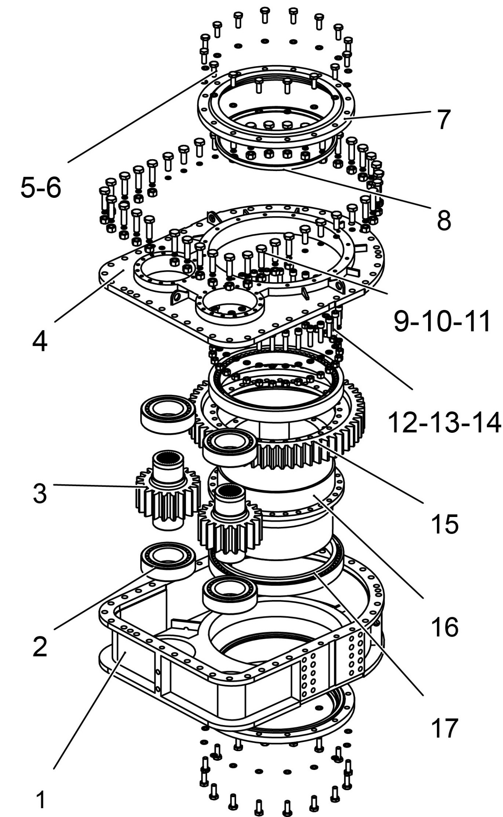
R10/R12 ROTARY TABLE
ITEM NO | PART NUMBER | Q’TY |  | DESCRIPTION
1 | 200001 | 1 |  | Main box
2 | 200002 | 4 |  | Bearing
3 | 200003 | 2 |  | Shaft
4 | 200004 | 1 |  | Cover
5 | 200005 | 32 |  | Screw
6 | 200006 | 32 |  | Washer
7 | 200007 | 2 |  | Housing
8 | 200008 | 2 |  | Oil retainer
9 | 200009 | 42 |  | Screw
10 | 200010 | 42 |  | Washer
11 | 200011 | 34 |  | Nut
12 | 200012 | 30 |  | Screw
13 | 200013 | 30 |  | Washer
14 | 200014 | 30 |  | Nut
15 | 200015 | 1 |  | Gear ring
16 | 200016 | 1 |  | Sleeve
17 | 200017 | 2 |  | Bearing
MAINTENANCE INSTRUCTION
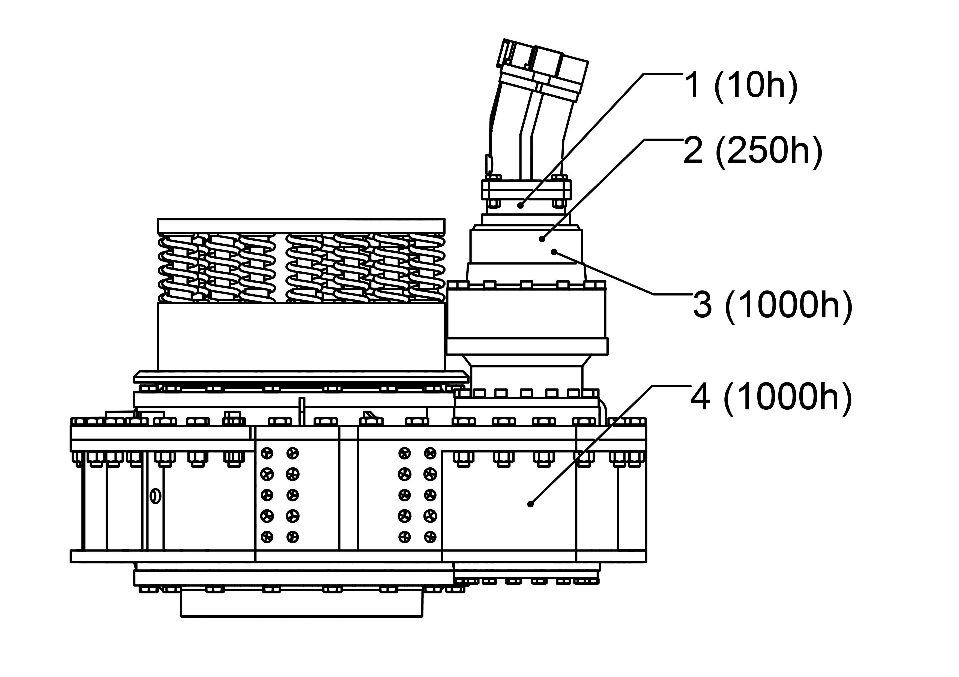

Items | Scope of work | Maintenance interval
1 | Check oil level of reduction gearbox | every day
2 | Check oil level of reduction box and refill if necessary | every 250 hours
3 | Change oil in reduction gearbox | every 1000 hours
4 | Change oil in main reduction gearbox | every 1000 hours
5 | Change oil in reduction gearbox and main reduction gearbox after first 50 hours
6 | Greasing the swivel each drilling shift
7 | Greasing all grease nipples every 50hours

Note: Using oil for reduction gearbox and main reduction gearbox: SAE 140 gear oil

